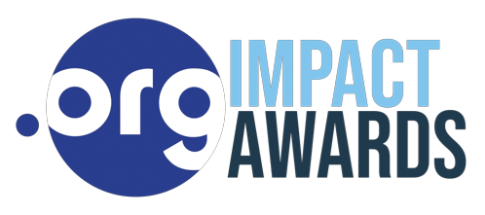
HISPAÑOLA HEALTH PARTNERS Named as a Finalist for the 2021 .ORG Impact Awards
Salisbury, CT, Hispañola Health Partners is pleased to announce that they have been selected as a finalist in the 3rd annual .ORG Impact Awards, which honors remarkable mission-driven organizations and individuals making their communities a better place. The awards are hosted by the Public Interest Registry (PIR).
Hispañola Health Partners is one of the top five entries in the Health and Healing in a Time of Pandemic category for providing primary care around the clock for the poorest citizens in isolated southeast Haiti. Their work in training traditional birth attendants is highlighted in this award. Birth attendants take courses on hygiene, safe birth practices, and the recognition of high-risk conditions, leading to better outcomes for moms and babies.
Submissions were reviewed and scored by a panel of judges who are leaders in the Internet, Non-profit, and Marketing sectors. All nominations were required to be tied to an active website with a .ORG domain.
“Our Haitian staff are proud to be awarded this honor, which affirms the hard work they do every day in an inhospitable environment. We thank all the supporters of Hispañola Health Partners who understand that a ground-up approach to health care in a low resource setting can successfully provide life-giving, sustainable healthcare to a marginalized people, so near to our shores,“ says Louise Lindenmeyr, Hispañola Health Partners’ Executive Director.
“The .ORG Impact Awards celebrate and showcase the incredible work that mission- driven organizations are doing in their communities and around the world,” said Jon Nevett, President and CEO of the Public Interest Registry. “This year was the most competitive ever—with 633 organizations from more than 40 countries submitting nominations across seven categories.”
This year’s finalists and winners will be celebrated as part of the 2021 .ORG Impact Awards—an online event November 9th that celebrates the range of challenges that the mission-driven community has overcome. Follow @PIRegistry on social media to find out more about the nominees and the event.
Interested parties should visit www.orgimpactawards.org for complete rules and information. More information about Hispañola Health Partners is accessible at their website: https://www.hispanolahealthpartners.org/, through Instagram: https://www.instagram.com/hispanola.health.partners/ and Facebook: https://www.facebook.com/HispanolaHealthPartners/
PIR media contact: Cassie Chechile, cassie@vrge.us, 240-463-0483

